Title of paper
First Author¹, Second Author², Third Author³
¹ Address of first author, including country, affiliation, and email address
² Same for second author
³ Same for subsequent authors

Keywords: please provide a maximum number of 5 keywords here

Add the body text here. This document explains how to prepare an extended abstract for the COST Action FP1303 Technical Workshop in Poznan on August 30-31, 2016. Please read the instructions carefully; they are formatted according to the guidelines and can be used as a template. If possible, please prepare your manuscript using ‘MS Word’ word processing software. The document should be saved under the first authors name, for example Jones.docx or Smith et al.doc. It can be save either as doc or docx format. DO NOT SEND IN PDF FORMAT. You may submit the document using e–mail to the Local Organiser (1303poznan@gmail.com), with a copy sent to Dennis Jones (dennis.jones@sp.se). The deadline is 17th of June 2016. All pictures, tables, and figures should be embedded in the text and centred. Top and margin is 3.5 cm, bottom margin and left margins are 3 cm, and the right margin is 2.5 cm. Do not place any text outside of this area. Do not include page numbers, they will be added later. Do not include headers and footers. The paper (regardless on the type of presentation) can be two pages long (including references). Please do not exceed these page limits.
All manuscripts should be in English. Metric units (SI) should be used. It is assumed that the corresponding authors grant us copyright to use the manuscript in the proceedings. Should the authors use tables or figures from other publications, it is assumed that permission has been obtained to do so. To emphasize a word or a phrase use italics, only use capitals or bold for the section headings.
Tables should be included in the text, where appropriate. A descriptive title should be given above the table in 10 pt. Calibri. Units should be given in square brackets. An example is given below (Table 1).
Table 1: Results of test
Specimen | Length [m] | Width [m] | Height [m] | Weight [kg]
1ª | 1 | 1 | 1 | 1
2 | 2 | 2 | 2 | 2
3^{b} | 3 | 3 | 3 | 3
ªComment a, ^{b}Comment b
Figures should be referred to in text as Fig. 1, or as (Fig. 1) and should be presented as part of the text. A descriptive title should be given bellow the figure in Calibri 10 pt.
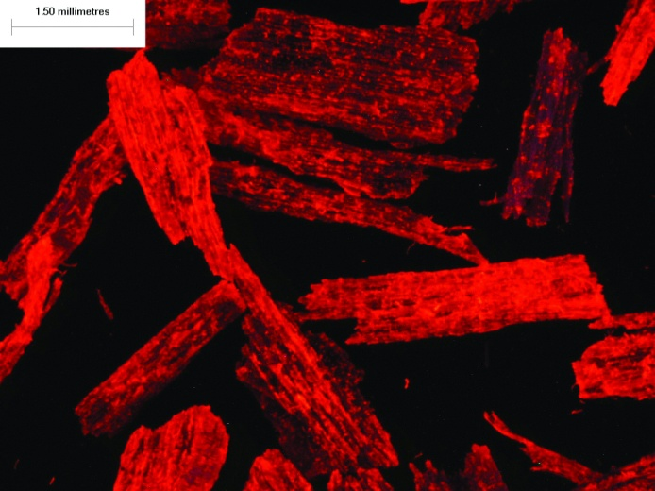
Figure 1: Image of blended particles at fluorescent light source

References
Please cite only the most important references (in Calibri 10 pt). Do not abbreviate journal titles. Cite references in the text using the author’s last name and date of publication as follows (Murphy 1990, Jones and Smith 1989, Davis et al. 1999). Please do not use programmes such as End-Point.
Example:
Buschbeck L., Kehr E., Jensen U. 1961a. Untersuchungen über die Eignung verschiedener Holzarten und Sortimente zur Herstellung von Spanplatten – 1. Mitteilung: Rotbuche und Kiefer. Holztechnologie, 2, 2: 99–110
Kollmann F., Kuenzi W. E., Stamm J. A. 1975. Principles of Wood Science and Technology – Volume II: Wood Based Materials. Berlin, Heidelberg, New York, Tokyo, Springer–Verlag: 312–550
Xu W., Suchsland O. 1998. Variability of particleboard properties from single– and mixed–species processes. Forest Products Journal, 48, 9: 68–74

Acknowledgments:

